DataMinig Pracrice Project Report

Task 1: Classification via Decision Trees and Naive Bayes
To start this task, I focused on the categorical side of the dataset. After removing any rows with missing values (the '?' marks), I dropped all numerical columns like age and capital gain to focus strictly on the multi-domain attributes. Because models like Decision Trees need numbers to work with, I used one-hot encoding to turn categories like 'Workclass' or 'Education' into binary features. I built a single Decision Tree using entropy to measure the quality of the splits and a Naive Bayes classifier to see how a probabilistic approach compared. For the final report, I calculated the TP and FP rates alongside the F1-score to get a full picture of how well the models could identify both high and low earners.
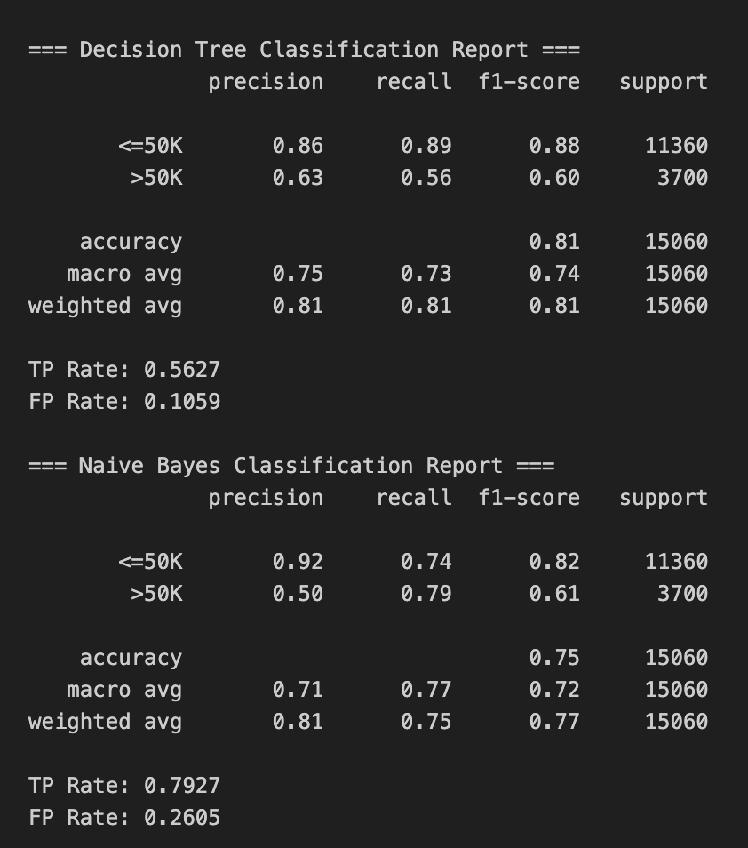

Task 2: Clustering and kNN with Binarized Data
In the second phase, I took a different approach to the data. Instead of dropping numerical values, I transformed them into binary bits. I calculated the average for each numerical column and assigned a '1' if the value was above that average and a '0' if it was below. For the clustering portion, I ran the K-Means algorithm with three different cluster settings (k = 3, 5, and 10) to see how the population naturally grouped together, and I've reported the resulting centroids for each. Finally, I used a kNN model to predict the income of the very last 10 people in the test set. I tested this with the same three 'k' values to observe how the local 'neighborhood' of data points influenced the accuracy of the predictions.
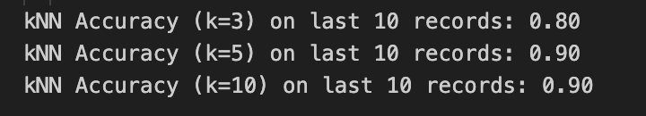

Task 3 & 4: SVM and Neural Networks
To wrap up the project, I applied the same binarized training data to two more advanced models: a Support Vector Machine (SVM) and a Neural Network. My goal here was to see if these more complex algorithms could pick up on patterns that the simpler models might have missed. I reported the overall accuracy for both to see which method provided the most reliable predictions for the census data.


